**DAA Assignment -1**

**- 21071A6788**

1 .Given a row wise sorted matrix of size **R*C** where R and C are always **odd**, find the median of the matrix. **5Marks**

**Test Case 1:**

**Input**:

R = 3, C = 3

M = [[1, 3, 5],

  [2, 6, 9],

  [3, 6, 9]]

**Output:** 5

**Explanation**: Sorting matrix elements gives

us {1,2,3,3,5,6,6,9,9}. Hence, 5 is median.

**Test Case 2:**

**Input:**

R = 3, C = 1

M = [[1], [2], [3]]

**Output:** 2

**Explanation**: Sorting matrix elements gives

us {1,2,3}. Hence, 2 is median.

* **Constraints:**  
  1 <= R, C <= 400  
  1 <= matrix[i][j] <= 2000

**Code(python):**

r=int(input('Enter number of rows: '))

c=int(input('Enter number of columns: '))

m=[]

print('Enter matrix elements: ')

for i in range(r):

a=list(map(int,input().split()))

m.append(a)

import numpy

median=numpy.median(m)

print(f'Median of elements of matrix is: {median}')

**Output-1:**

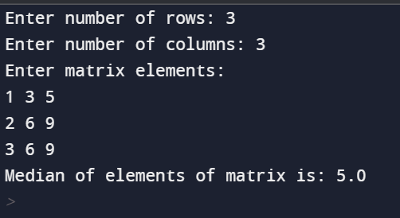

**Output-2:**

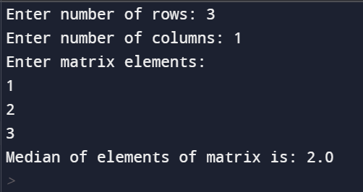

2. Given the arrival and departure times of all trains that reach a railway station, the task is to find the minimum number of platforms required for the railway station so that no train waits. We are given two arrays that represent the arrival and departure times of trains that stop. **5Marks**

**Test case 1**

***Input:****arr[] = {9:00, 9:40, 9:50, 11:00, 15:00, 18:00}, dep[] = {9:10, 12:00, 11:20, 11:30, 19:00, 20:00}****Output:****3****Explanation:****There are at-most three trains at a time (time between 9:40 to 12:00)*

**Test case 2**

***Input:****arr[] = {9:00, 9:40}, dep[] = {9:10, 12:00}****Output:****1****Explanation:****Only one platform is needed.*

**Code(C++):**

#include<iostream>

#include<algorithm>

using namespace std;

int func(int,int[],int[]);

int func(int n,int arr[],int dept[]){

sort(arr,arr+n);

sort(dept,dept+n);

int i=1,j=0,c=1,maxc=1;

while(i<n&&j<n){

if(arr[i]<=dept[j]){

c++;

i++;

}

else if(arr[i]>dept[j]){

c--;

j++;

}

if(c>maxc)

c=maxc;

}

return c;

}

int main(){

int n,i;

cout<<"enter:";

cin>>n;

int arr[n],dept[n];

cout<<"Enter arrival times:"<<endl;

for(i=0;i<n;i++){

cin>>arr[i];

}

cout<<"Enter departure times:"<<endl;

for(i=0;i<n;i++){

cin>>dept[i];

}

cout<<"No of platforms required:"<<func(n,arr,dept);

}

**Output-1:**

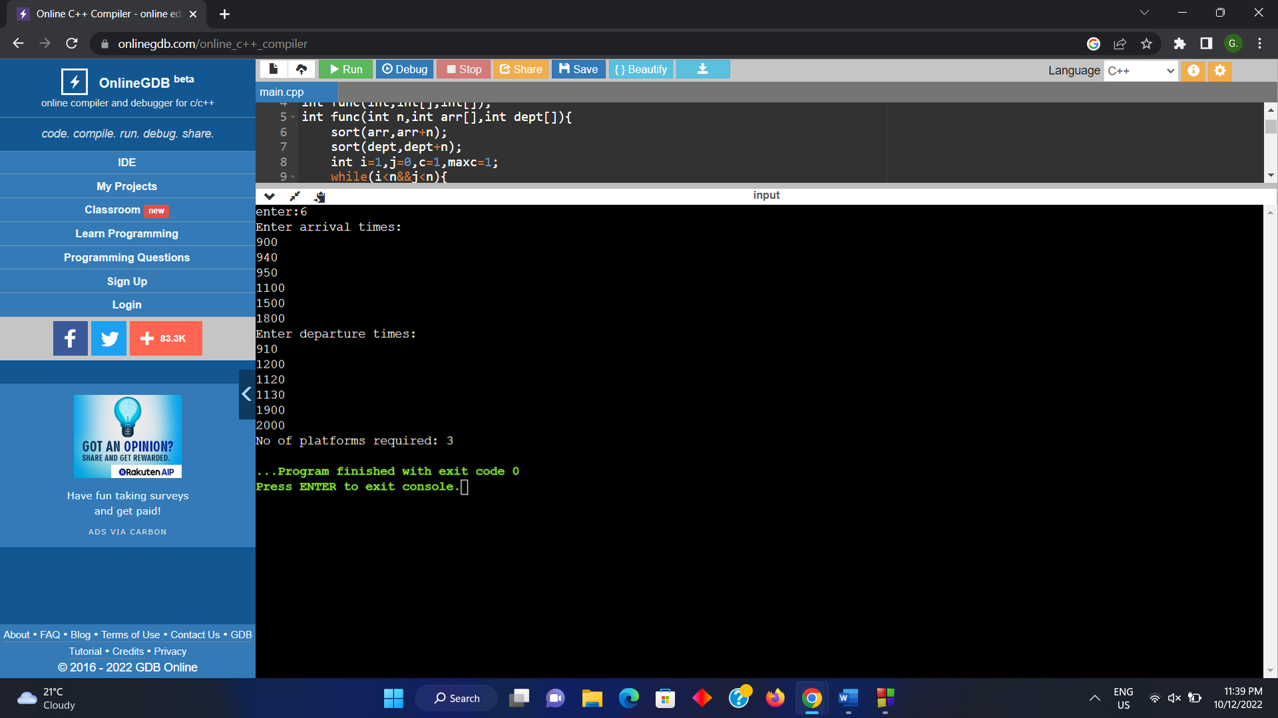

**Output-2:**

